

Funeral Services
PRICE GUIDE
Planning a funeral service, burial or cremation

Burial Services at Merritt Funeral Services
Burials require the purchase of a grave and also an intermit fee. These fees are determined on the cemetery and type of grave selected. The purchase of the grade and intermit fees must be arranged and paid directly through you Cemetery of Choice.
Professional Service Fees include
- 24hr, 7 days personal and professional care
- Private arrangement in the comfort of your family home or our office
- Attend to relevant administration
- Collection of medical certificate
- Transport of your loved one to the graveside on the day of the service

Graveside Service  Service held at the graveside  Professional Service Fee – $3,500  Additional Costs  - Death Medical Certificate $80.00  - Cemetery Fees at costs  - Purchase of Grave (they vary depending on Cemetery)  - Interment Costs (they vary depending on Cemetery)  - Coffins from $990.00  - Transfer of loved one $300.00 (if after hours only)  - Celebrant fees from $450.00  - Clergy fees from $250.00  - Floral Tributes (at cost)  - Newspaper Notices (at cost)  - Order of services booklets: from $5.00  - Limo / Family Coach (at cost)  - Dressing / Mortuary care for viewing from $500.00  - Viewing night before $200.00 (or after hours)  - Weekend or Public Holidays  (at cost)  - Refreshments can be arranged (at cost) | Chapel Service & Burial  Services is held at Merritts Funeral Services Chapel followed by a graveside services within the Cemetery grounds  Professional Service Fee – $3,500  Additional Costs  - Cemetery Fees at costs  - Purchase of Grave (they vary depending on Cemetery)  - Interment Costs (they vary depending on Cemetery)  - Coffins from $990.00  - Transfer of loved one $300.00 (if after hours only)  - Celebrant fees from $450.00  - Clergy fees from $250.00  - Floral Tributes (at cost)  - Newspaper Notices (at cost)  - DVD Presentation from $350.00  - Order of services booklets: from $5.00  - Limo / Family Coach (at cost)  - Dressing / Mortuary care for viewing from $500.00  - Viewing night before $200.00 (or after hours)  - Weekend or Public Holidays (at cost)  - We can organise refreshments at your request (at cost) | Church or Alternative Venue  Services held in a church or alternative venue. Followed by graveside services at the Cemetery  Professional Service Fee – $4,000  Additional Costs  - Cemetery Fees at costs  - Purchase of Grave ( they vary depending on Cemetery)  - Interment Costs ( they vary depending on Cemetery)  - Coffins from $990.00  - Celebrant fees $450.00  - Church fees from $500.00  - Clergy fees from $250.00  - Alternative venue (at cost)  - Floral Tributes (at cost)  - Newspaper Notices (at cost)  - DVD Presentation from $350.00  - Order of services booklets: from $5.00 per booklet  - Limo / family Coach (at cost)  - Dressing / Mortuary care for viewing from $500.00  - Weekend or Public Holidays (at cost)  - Refreshments can be arranged (at cost)

Affordable Funeral & Cremation Services
at Merritt Funeral Services
At Merritt Funeral Services we offer many varieties of Affordable funeral and cremation services in the Goulburn Valley from an Straight Cremation with no one in attendance. To helping you create an individual tailor made funeral services that best represents, your family and your loved ones life.
Professional Service Fees include
- 24hr, 7 days personal and professional care
- Cremation Fee
- Arrangement with funeral consultant via phone or email
- Attend to relevant administration
- Collection of medical certificate
- Transport of your loved one to the crematorium/service
- Infant Child
- Newborn to Toddler – No Charge
- Cemetery at Cost

The Bare Essential Cremation  Cremation to be held at Murray Valley Crematorium or Cremations Moama  Professional Service Fee – $4,000 + GST  Full payment to be made prior to booking cremation | Affordable Cremation  A service held in a Chapel, Church or unique venue, followed by a private cremation  Professional Service Fee – $3,500  - Includes arrangement in the comfort of your own home or our office.  - Death Certificate (mailed directly to you)  - Return of your loved ones ashes.  Additional Cost  - Cremation and Chapel fee from $1300.00  - Coffin from $990.00  - Celebrant fees from $450.00  - Clergy Fee from $250.00  - Dressing/Mortuary care for viewing from $500.00  - Viewing night before service or after hours $200.00  - Alternative venue/church (at cost)  - Newspaper notices (at cost)  - Weekend or Public Holidays – crematorium & cemetery (at cost)  - DVD presentation from $350.00  - Order of service booklets from $5.00  Full Payment Required prior to booking cremation.

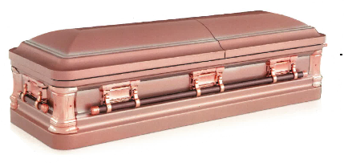
SICH RANGE

ROSETTA $10,000 + GST

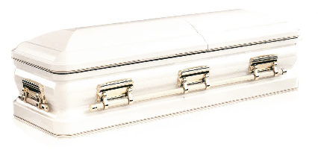

WENTWORTH $10,000 + GST




EBONY
$10,000 + GST
HERITAGE
$10,000 + GST

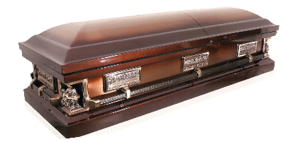
PIETA CLASSIC $10,000 + GST
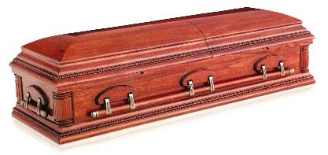
WINSTON $7,000 + GST

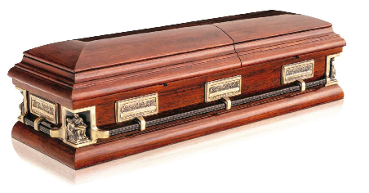
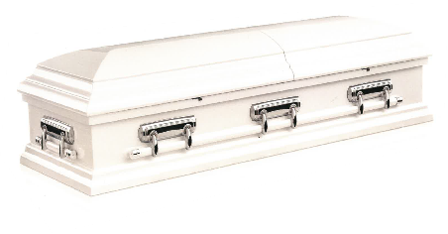


PIETA

GUARDIAN
$7,000 + GST

$7,000 + GST

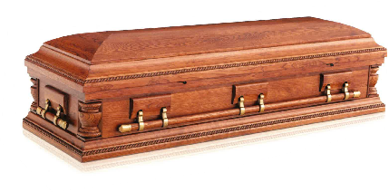
MONTCLAIR $7,000 + GST

WINGSOR $8,000 + GST

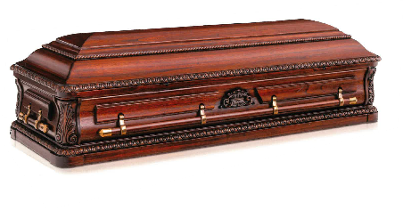
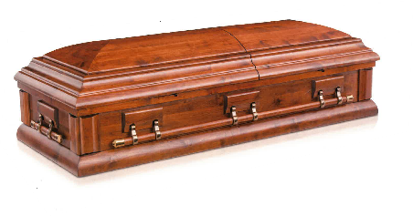
FLINDERS

BOWEN
$7,000 + GST

$7,000 + GST





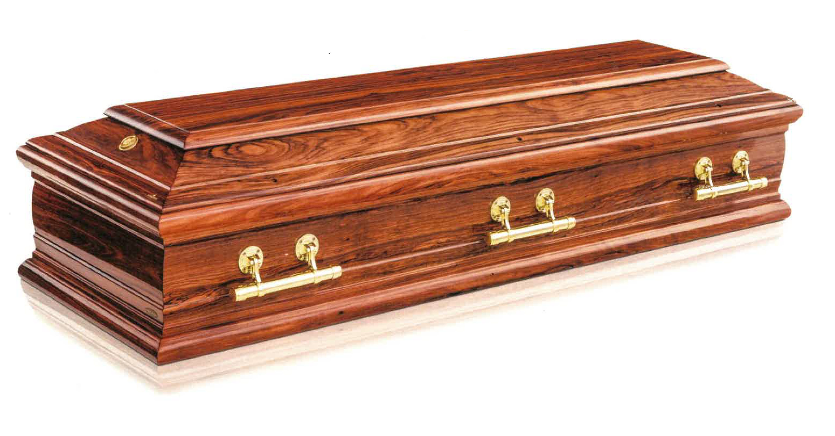
EUROPAG RANGE
SIENNA
$6,000 + GST
VERONA
$6,000 + GST
MILANO
$6,000 + GST


ROME
$6,000 + GST


MONTELLO $6,000 + GST



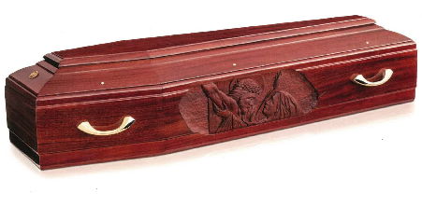
TREVISO $6,000 + GST

CARITA $6,000 + GST

TIMBER RANGE
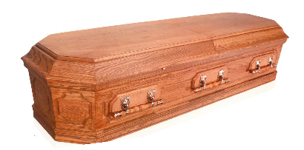
CRECIAN URN $5,000 + GST

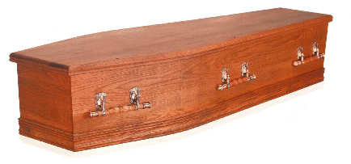
OXFORD $2,500 + GST
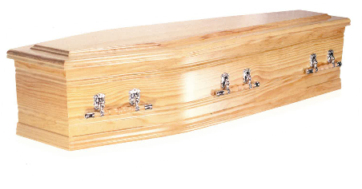
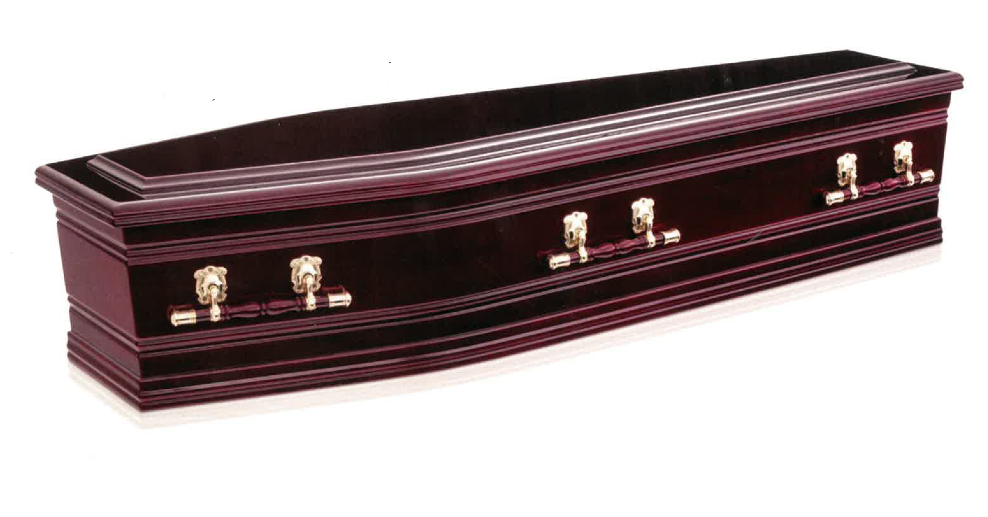
GLENMORE
$2,500 + GST
ASCOT
$2,500 + GST

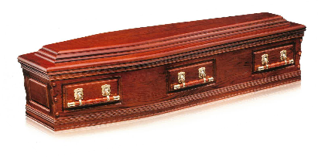
DENMAN $3,000 + GST

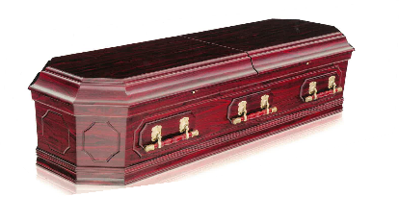
PAPER VENEER RANGE

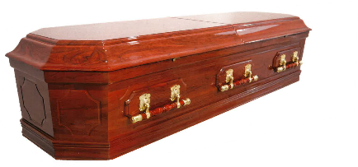

GRECIAN URN $4,000 + GST

GRECIAN URN $4,000 + GST

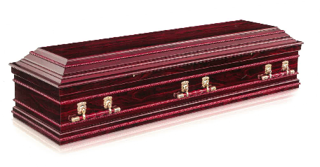
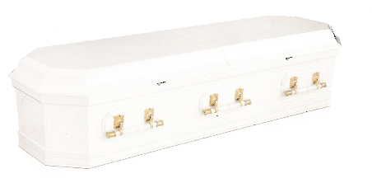
GRECIAN URN $4,000 + GST
FLORENCE
$4,000 + GST

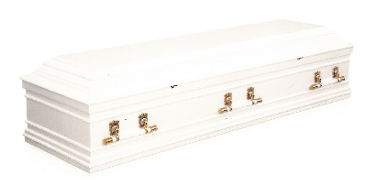
FLORENCE $4,000 + GST

AVONDALE $2,500 + GST

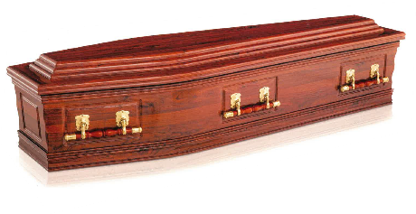
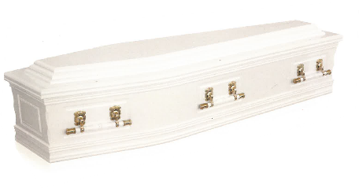
AVONDALE

AVONDALE
$2,500 + GST

$2,500 + GST

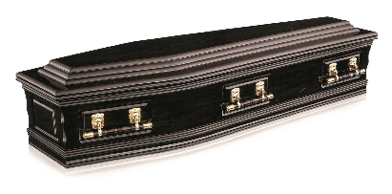
AVONDALE $2,500 + GST

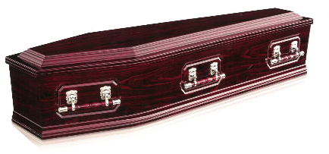

DAVIDSON $2,300 + GST

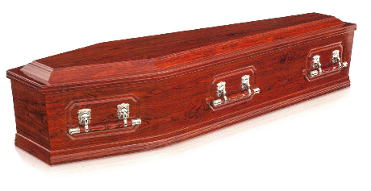
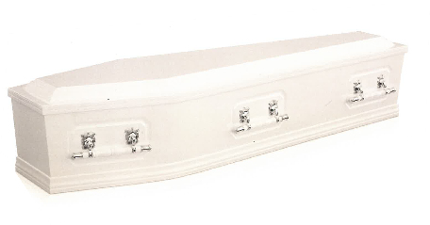
DAVIDSON

DAVIDSON
$2,300 + GST

$2,300 + GST

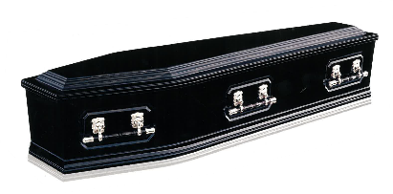
DAVIDSON $2,300 + GST

SILVERTON $2,000 + GST

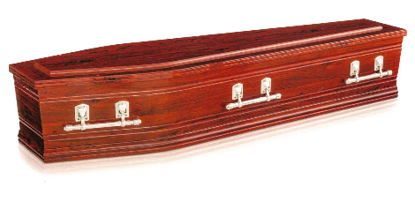




SILVERTON

SILVERTON
$2,000 + GST

$2,000 + GST

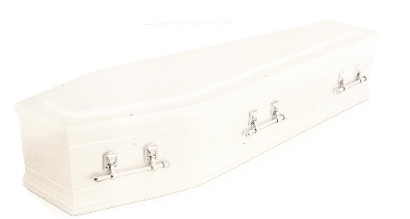
CALVARY $2,000 + GST
CALVARY
$2,000 + GST

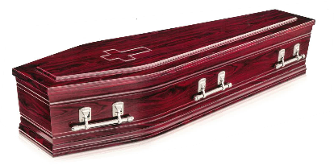




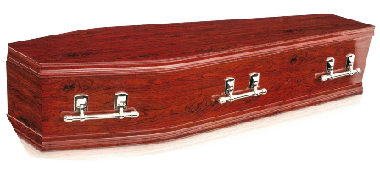




RICHMOND

RICKMOND
$1,900 + GST

$1,900 + GST

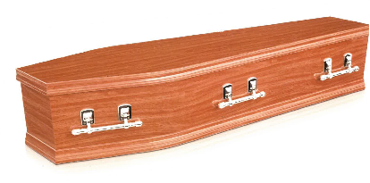





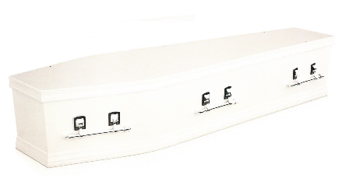



RICKMOND $1,900 + GST
RICKMOND
$1,900 + GST

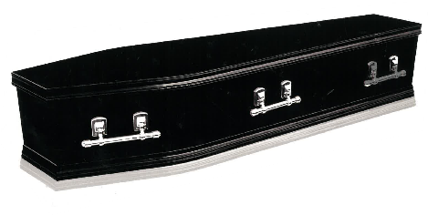

RICHMOND $1,900 + GST

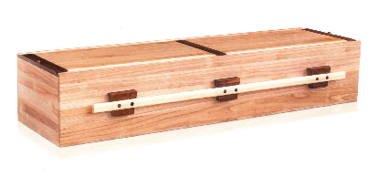
GREEN NATURE RANGE

FORESTER $3,000 + GST

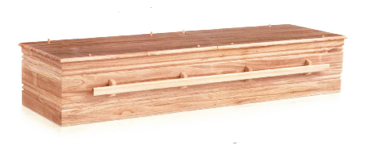
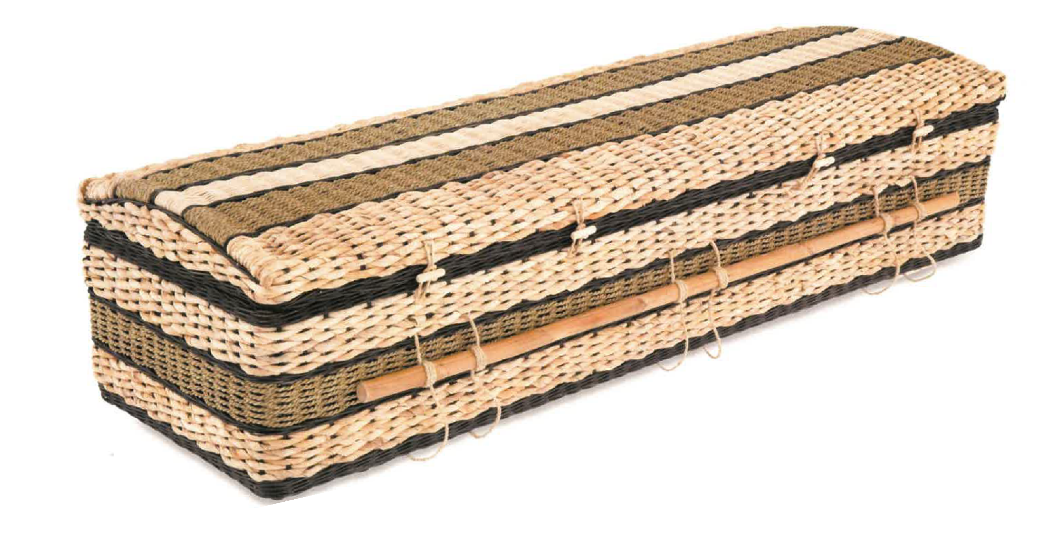
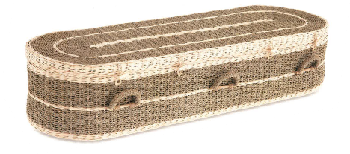
PANDANUS $4,000 + GST
ENVIRO
$3,000 + GST
BANANA
$4,000 + GST

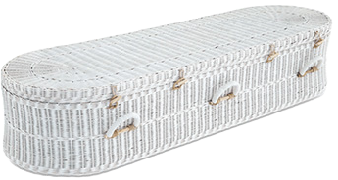
WHITE WOCKER $3,000 + GST


KUBU $4,000 + GST

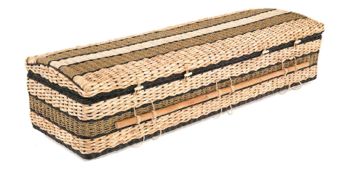
BANANA $4,000 + GST

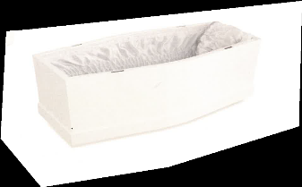
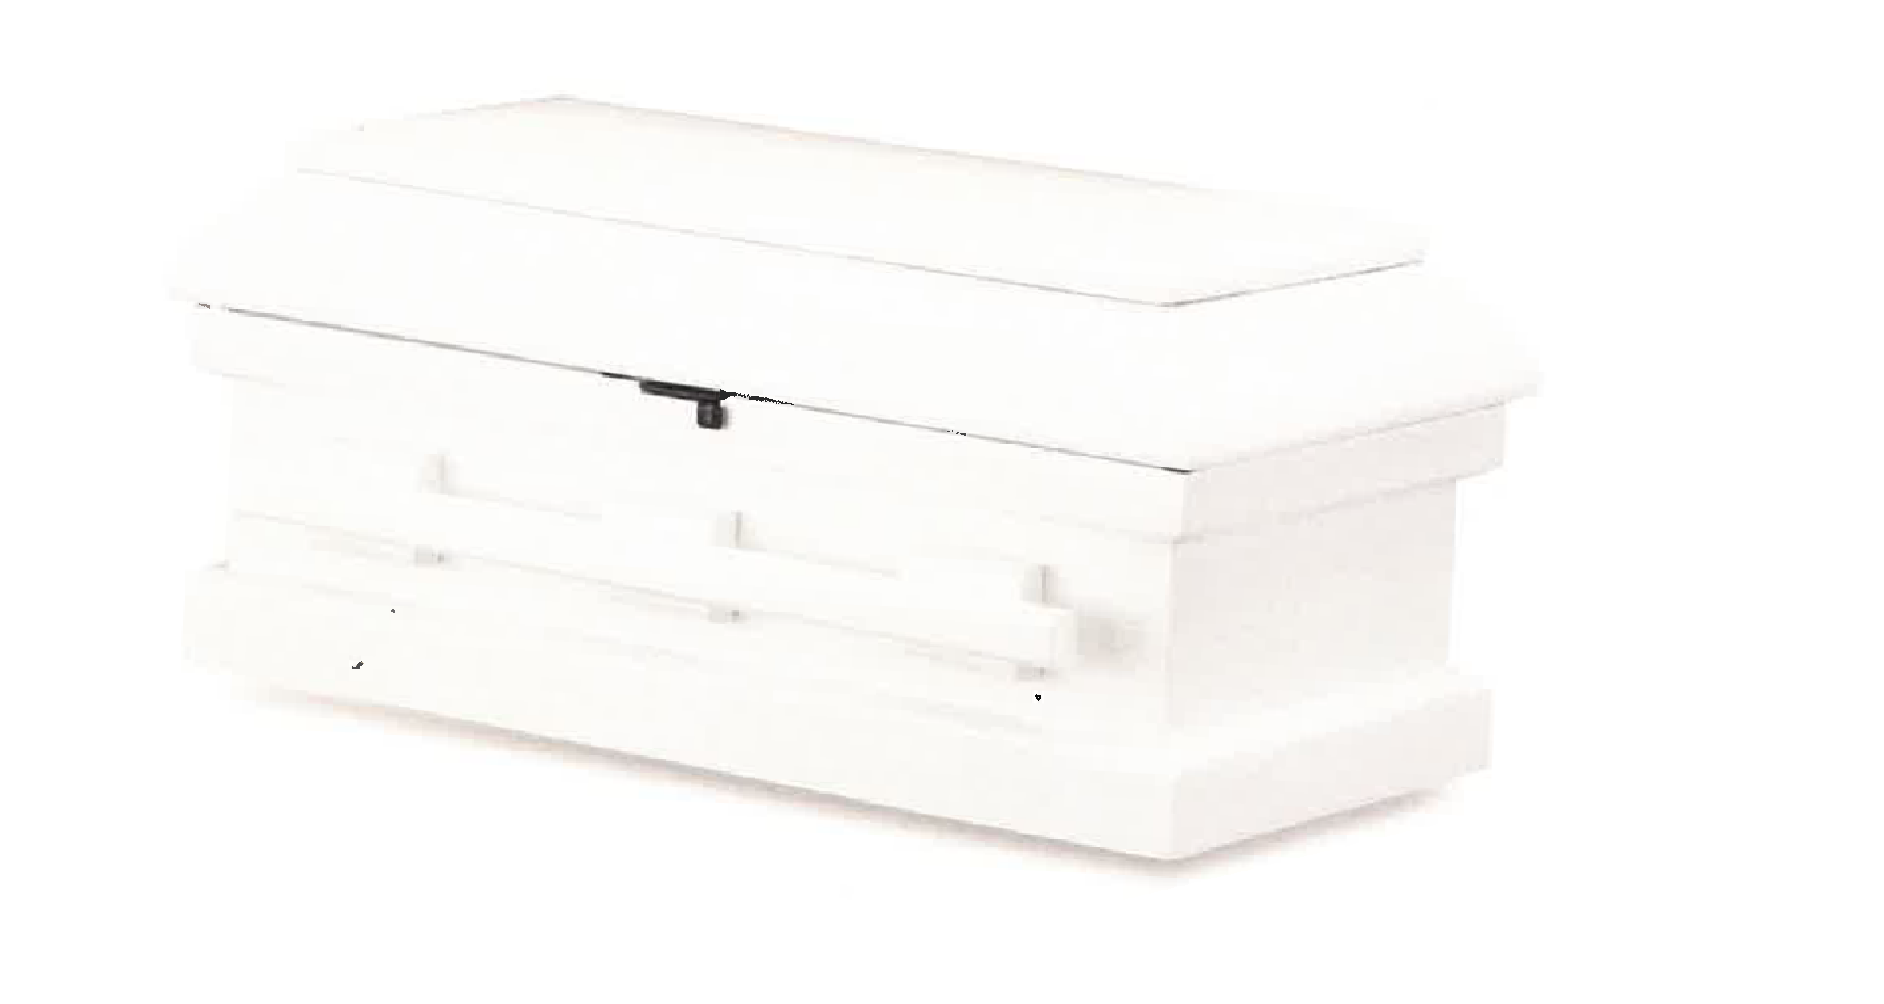
CHILDREN’S RANGE
BABY & INFANT
NO CHARGE

EDEN BABY NO CHARGE

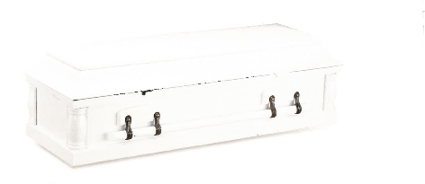


EDEN CHILD

NO CHARGE

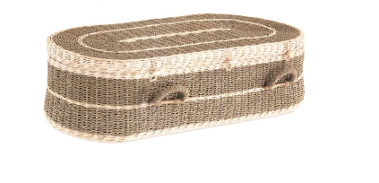
BABY PANDANUS
NO CHARGE

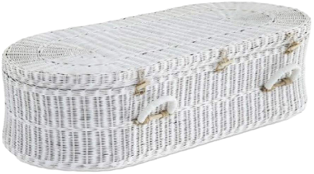

BABY WICKER NO CHARGE

